LAPORAN PRAKTIKUM
APLIKASI BERBASIS PLATFORM

MODUL 5
Bootstrap


Disusun oleh:
YASVIN SYAHGANA
2311102065
S1 IF-04

Dosen Pengampu:
Dedy Agung Prabowo, S.Kom., M.Kom

PROGRAM STUDI S1 TEKNIK INFORMATIKA
FAKULTAS DIREKTORAT KAMPUS PURWOKERTO
UNIVERSITAS TELKOM
2026
LINK GIT :
https://github.com/yasvinsyahgana/Laporan-Praktikum-ABP

MODUL 5
Bootstrap
halaman web profil mahasiswa sederhana menggunakan framework Bootstrap 5.

- Installasi Bootstrap (CDN)
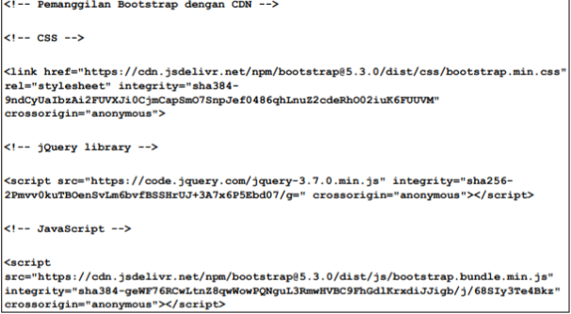
Output:
File HTML untuk Testing Instalasi:
<!DOCTYPE html>
<html lang="id">
<head>
<meta charset="UTF-8">
<meta name="viewport" content="width=device-width, initial-scale=1.0">
<title>Test Instalasi Bootstrap</title>

<!-- Bootstrap CSS CDN -->
<link href="https://cdn.jsdelivr.net/npm/bootstrap@5.3.0/dist/css/bootstrap.min.css" rel="stylesheet">
</head>
<body>

<div class="container mt-5">
<h1 class="text-center text-primary">Bootstrap Berhasil Diinstall!</h1>
<div class="alert alert-success mt-4 text-center">
<strong>Sukses!</strong> Framework Bootstrap 5 sudah terhubung dengan benar.
</div>
<button class="btn btn-primary d-block mx-auto">Ini Tombol Bootstrap</button>
</div>

<!-- Bootstrap JavaScript CDN -->
<script src="https://cdn.jsdelivr.net/npm/bootstrap@5.3.0/dist/js/bootstrap.bundle.min.js"></script>
</body>
</html>
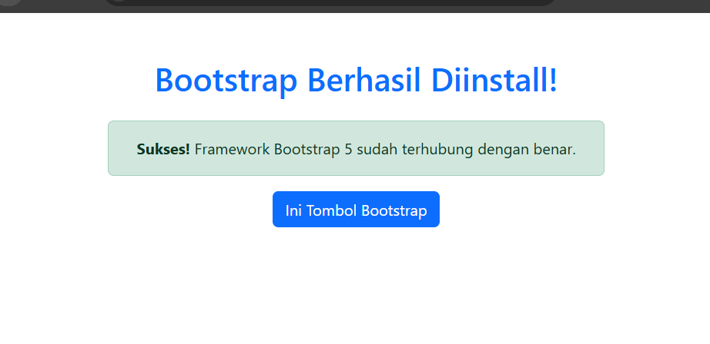
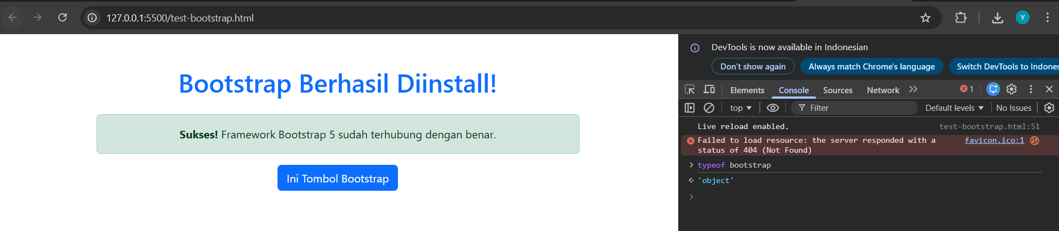
- Bootstrap Grid System
Bootstrap Grid System terdiri dari 3 komponen utama:
- Container - Wrapper/pembungkus
- Row - Baris
- Column - Kolom (maksimal 12 kolom per row)
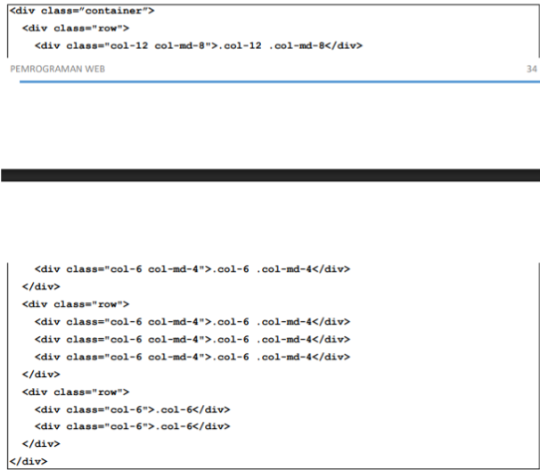

- <!DOCTYPE html>
- <html lang="id">
- <head>
- <meta charset="UTF-8">
- <meta name="viewport" content="width=device-width, initial-scale=1.0">
- <title>Bootstrap Grid System</title>
- <link href="https://cdn.jsdelivr.net/npm/bootstrap@5.3.0/dist/css/bootstrap.min.css" rel="stylesheet">
- <style>
- .box {
- background-color: #4CAF50;
- color: white;
- text-align: center;
- padding: 20px;
- margin: 10px 0;
- border-radius: 5px;
- }
- </style>
- </head>
- <body>

- <div class="container mt-5">
- <h1 class="text-center mb-5">Demo Bootstrap Grid System</h1>

- <!-- Contoh 1: 2 Kolom Sama Besar -->
- <h3>1. Dua Kolom (6 + 6 = 12)</h3>
- <div class="row">
- <div class="col-md-6">
- <div class="box">Kolom 1<br>(col-md-6)</div>
- </div>
- <div class="col-md-6">
- <div class="box">Kolom 2<br>(col-md-6)</div>
- </div>
- </div>

- <!-- Contoh 2: 3 Kolom Sama Besar -->
- <h3>2. Tiga Kolom (4 + 4 + 4 = 12)</h3>
- <div class="row">
- <div class="col-md-4">
- <div class="box">Kolom 1<br>(col-md-4)</div>
- </div>
- <div class="col-md-4">
- <div class="box">Kolom 2<br>(col-md-4)</div>
- </div>
- <div class="col-md-4">
- <div class="box">Kolom 3<br>(col-md-4)</div>
- </div>
- </div>

- <!-- Contoh 3: 4 Kolom -->
- <h3>3. Empat Kolom (3 + 3 + 3 + 3 = 12)</h3>
- <div class="row">
- <div class="col-md-3">
- <div class="box">Kolom 1<br>(col-md-3)</div>
- </div>
- <div class="col-md-3">
- <div class="box">Kolom 2<br>(col-md-3)</div>
- </div>
- <div class="col-md-3">
- <div class="box">Kolom 3<br>(col-md-3)</div>
- </div>
- <div class="col-md-3">
- <div class="box">Kolom 4<br>(col-md-3)</div>
- </div>
- </div>

- <!-- Contoh 4: Kolom Tidak Sama -->
- <h3>4. Kolom Tidak Sama (8 + 4 = 12)</h3>
- <div class="row">
- <div class="col-md-8">
- <div class="box">Kolom Lebar<br>(col-md-8)</div>
- </div>
- <div class="col-md-4">
- <div class="box">Kolom Sempit<br>(col-md-4)</div>
- </div>
- </div>

- <!-- Contoh 5: Responsive Grid -->
- <h3>5. Responsive Grid (Berubah di Mobile)</h3>
- <div class="row">
- <div class="col-12 col-md-6 col-lg-4">
- <div class="box">Item 1<br>(col-12 col-md-6 col-lg-4)</div>
- </div>
- <div class="col-12 col-md-6 col-lg-4">
- <div class="box">Item 2<br>(col-12 col-md-6 col-lg-4)</div>
- </div>
- <div class="col-12 col-md-6 col-lg-4">
- <div class="box">Item 3<br>(col-12 col-md-6 col-lg-4)</div>
- </div>
- </div>

- </div>

- <script src="https://cdn.jsdelivr.net/npm/bootstrap@5.3.0/dist/js/bootstrap.bundle.min.js"></script>
- </body>
- </html>

Output:
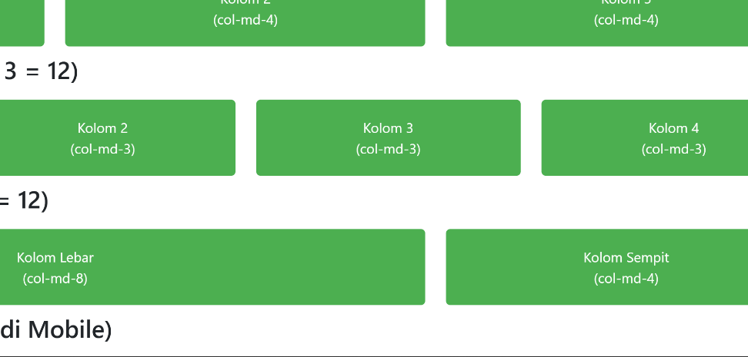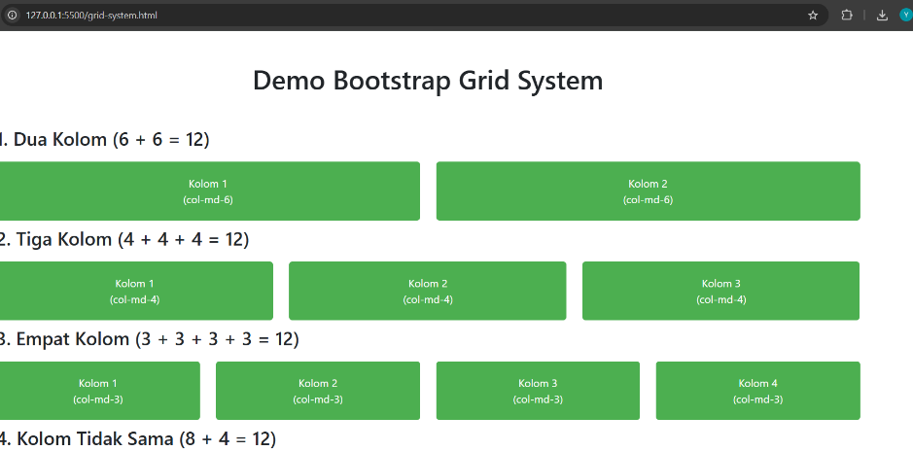

- Bootstrap Table
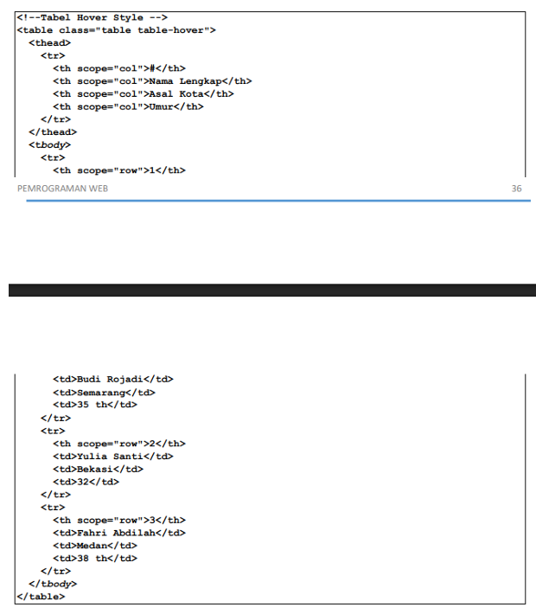
<!DOCTYPE html>
<html lang="id">
<head>
<meta charset="UTF-8">
<meta name="viewport" content="width=device-width, initial-scale=1.0">
<title>Bootstrap Table</title>
<link href="https://cdn.jsdelivr.net/npm/bootstrap@5.3.0/dist/css/bootstrap.min.css" rel="stylesheet">
</head>
<body>

<div class="container mt-5">
<h1 class="text-center mb-5">Demo Bootstrap Table</h1>

<!-- Tabel 1: Tabel Dasar dengan Hover -->
<h3>1. Tabel Data Mahasiswa (table-hover)</h3>
<table class="table table-hover">
<thead class="table-dark">
<tr>
<th scope="col">No</th>
<th scope="col">NIM</th>
<th scope="col">Nama</th>
<th scope="col">Jurusan</th>
<th scope="col">IPK</th>
</tr>
</thead>
<tbody>
<tr>
<th scope="row">1</th>
<td>2026001</td>
<td>Ahmad Rizki</td>
<td>Teknik Informatika</td>
<td>3.75</td>
</tr>
<tr>
<th scope="row">2</th>
<td>2026002</td>
<td>Siti Nurhaliza</td>
<td>Sistem Informasi</td>
<td>3.82</td>
</tr>
<tr>
<th scope="row">3</th>
<td>2026003</td>
<td>Budi Santoso</td>
<td>Teknik Komputer</td>
<td>3.65</td>
</tr>
<tr>
<th scope="row">4</th>
<td>2026004</td>
<td>Dewi Lestari</td>
<td>Teknik Informatika</td>
<td>3.90</td>
</tr>
</tbody>
</table>

<!-- Tabel 2: Tabel dengan Striped dan Bordered -->
<h3>2. Tabel Jadwal Kuliah (table-striped table-bordered)</h3>
<table class="table table-striped table-bordered">
<thead class="table-primary">
<tr>
<th scope="col">Hari</th>
<th scope="col">Jam</th>
<th scope="col">Mata Kuliah</th>
<th scope="col">Ruang</th>
<th scope="col">Dosen</th>
</tr>
</thead>
<tbody>
<tr>
<td>Senin</td>
<td>08:00 - 10:00</td>
<td>Pemrograman Web</td>
<td>R.301</td>
<td>Pak Andi</td>
</tr>
<tr>
<td>Selasa</td>
<td>10:00 - 12:00</td>
<td>Basis Data</td>
<td>R.205</td>
<td>Bu Siti</td>
</tr>
<tr>
<td>Rabu</td>
<td>13:00 - 15:00</td>
<td>Struktur Data</td>
<td>R.301</td>
<td>Pak Budi</td>
</tr>
<tr>
<td>Kamis</td>
<td>08:00 - 10:00</td>
<td>Jaringan Komputer</td>
<td>Lab. Jaringan</td>
<td>Pak Doni</td>
</tr>
</tbody>
</table>

<!-- Tabel 3: Tabel dengan Warna Status -->
<h3>3. Tabel Status Pembayaran (dengan warna)</h3>
<table class="table table-bordered">
<thead class="table-success">
<tr>
<th scope="col">No</th>
<th scope="col">NIM</th>
<th scope="col">Nama</th>
<th scope="col">Status</th>
</tr>
</thead>
<tbody>
<tr class="table-success">
<th scope="row">1</th>
<td>2026001</td>
<td>Ahmad Rizki</td>
<td>Lunas ✓</td>
</tr>
<tr class="table-success">
<th scope="row">2</th>
<td>2026002</td>
<td>Siti Nurhaliza</td>
<td>Lunas ✓</td>
</tr>
<tr class="table-warning">
<th scope="row">3</th>
<td>2026003</td>
<td>Budi Santoso</td>
<td>Pending ⏳</td>
</tr>
<tr class="table-danger">
<th scope="row">4</th>
<td>2026004</td>
<td>Dewi Lestari</td>
<td>Belum Lunas ✗</td>
</tr>
</tbody>
</table>

<!-- Tabel 4: Tabel Responsif -->
<h3>4. Tabel Responsif (table-responsive)</h3>
<p class="text-muted">Resize browser untuk melihat scroll horizontal</p>
<div class="table-responsive">
<table class="table table-striped table-hover">
<thead class="table-dark">
<tr>
<th>No</th>
<th>NIM</th>
<th>Nama Lengkap</th>
<th>Email</th>
<th>No. Telepon</th>
<th>Alamat</th>
<th>Jurusan</th>
<th>Semester</th>
</tr>
</thead>
<tbody>
<tr>
<td>1</td>
<td>2026001</td>
<td>Ahmad Rizki Pratama</td>
<td>ahmad@email.com</td>
<td>081234567890</td>
<td>Jl. Merdeka No. 123</td>
<td>Teknik Informatika</td>
<td>5</td>
</tr>
<tr>
<td>2</td>
<td>2026002</td>
<td>Siti Nurhaliza</td>
<td>siti@email.com</td>
<td>081234567891</td>
<td>Jl. Sudirman No. 456</td>
<td>Sistem Informasi</td>
<td>5</td>
</tr>
</tbody>
</table>
</div>

</div>

<script src="https://cdn.jsdelivr.net/npm/bootstrap@5.3.0/dist/js/bootstrap.bundle.min.js"></script>
</body>
</html>

Output:
mentah
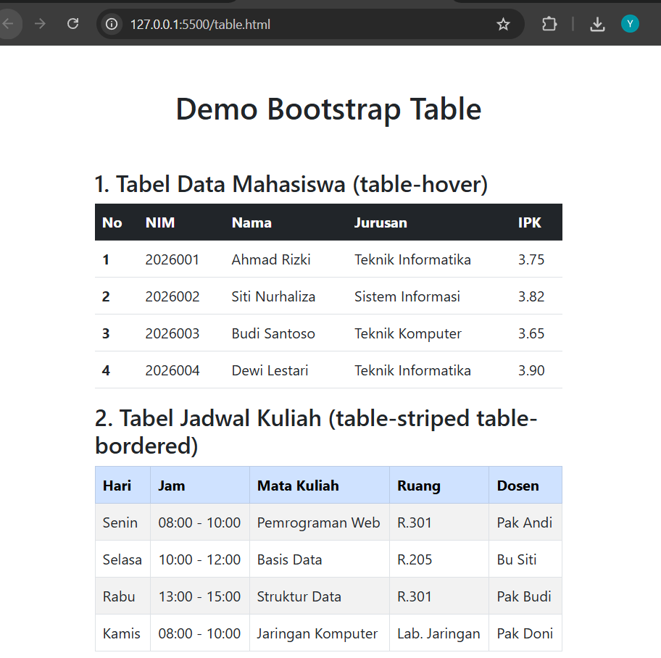
Setelah di hover ( kursor di arahkan)
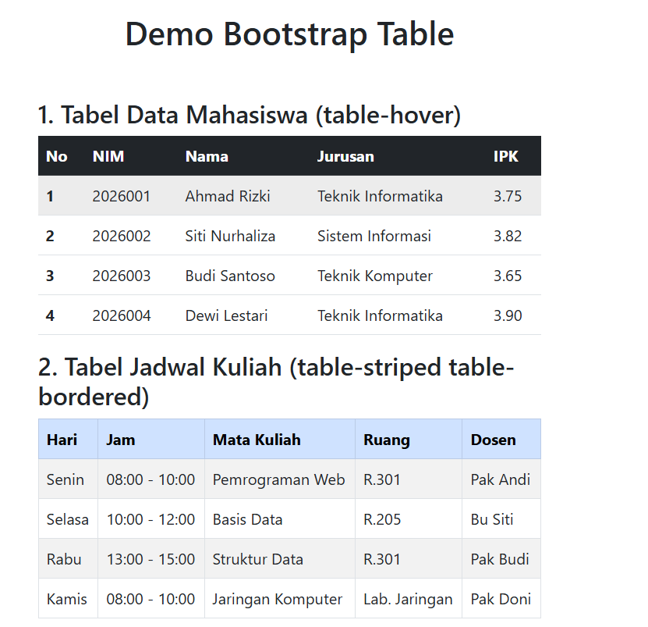

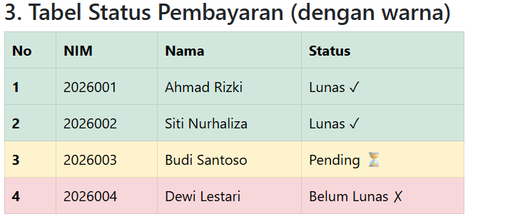
Resposive vertikal
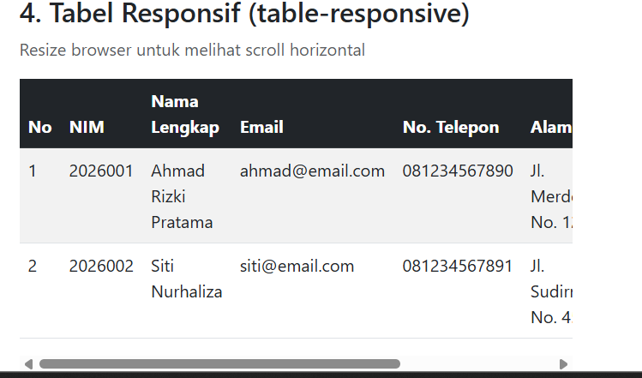
Tabel 1 - Dasar:
- table-hover → Baris berubah warna saat di-hover
- table-dark pada thead → Header berwarna gelap
Tabel 2 - Striped & Bordered:
- table-striped → Baris selang-seling warna
- table-bordered → Border pada setiap sel
- table-primary → Header biru
Tabel 3 - Warna Status:
- table-success (hijau) → Lunas
- table-warning (kuning) → Pending
- table-danger (merah) → Belum Lunas
Tabel 4 - Responsive:
- table-responsive → Scroll horizontal di layar kecil
- Berguna untuk tabel dengan banyak kolom

- Bootstrap Image
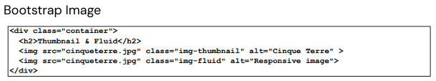
Implementas:
<!DOCTYPE html>
<html lang="id">
<head>
<meta charset="UTF-8">
<meta name="viewport" content="width=device-width, initial-scale=1.0">
<title>Bootstrap Image</title>
<link href="https://cdn.jsdelivr.net/npm/bootstrap@5.3.0/dist/css/bootstrap.min.css" rel="stylesheet">
</head>
<body>

<div class="container mt-5">
<h2 class="text-center mb-5">Demo Bootstrap Image</h2>

<!-- 1. Image Fluid (Responsif) -->
<h4>1. Gambar Responsif (img-fluid)</h4>
<p class="text-muted">Resize browser, gambar akan menyesuaikan lebar layar.</p>
<img src="https://picsum.photos/800/300" class="img-fluid" alt="Gambar Responsif">
<hr>

<!-- 2. Image Thumbnail -->
<h4>2. Thumbnail Style (img-thumbnail)</h4>
<img src="https://picsum.photos/200/200" class="img-thumbnail" alt="Thumbnail">
<hr>

<!-- 3. Rounded Shapes -->
<h4>3. Bentuk Sudut Gambar</h4>
<div class="row text-center">
<div class="col-md-4">
<img src="https://picsum.photos/150/150" class="rounded" alt="Rounded">
<p class="mt-2">rounded</p>
</div>
<div class="col-md-4">
<img src="https://picsum.photos/150/150" class="rounded-circle" alt="Circle">
<p class="mt-2">rounded-circle</p>
</div>
<div class="col-md-4">
<img src="https://picsum.photos/200/100" class="rounded-pill" alt="Pill">
<p class="mt-2">rounded-pill</p>
</div>
</div>

<!-- 4. Image dalam Card (Contoh Penggunaan Nyata) -->
<h4 class="mt-4">4. Gambar dalam Komponen (Contoh Card)</h4>
<div class="card" style="width: 18rem;">
<img src="https://picsum.photos/300/200" class="card-img-top" alt="Card Image">
<div class="card-body">
<h5 class="card-title">Judul Card</h5>
<p class="card-text">Contoh penggunaan gambar di dalam komponen Bootstrap Card.</p>
<a href="#" class="btn btn-primary">Lihat Detail</a>
</div>
</div>

</div>

<script src="https://cdn.jsdelivr.net/npm/bootstrap@5.3.0/dist/js/bootstrap.bundle.min.js"></script>
</body>
</html>

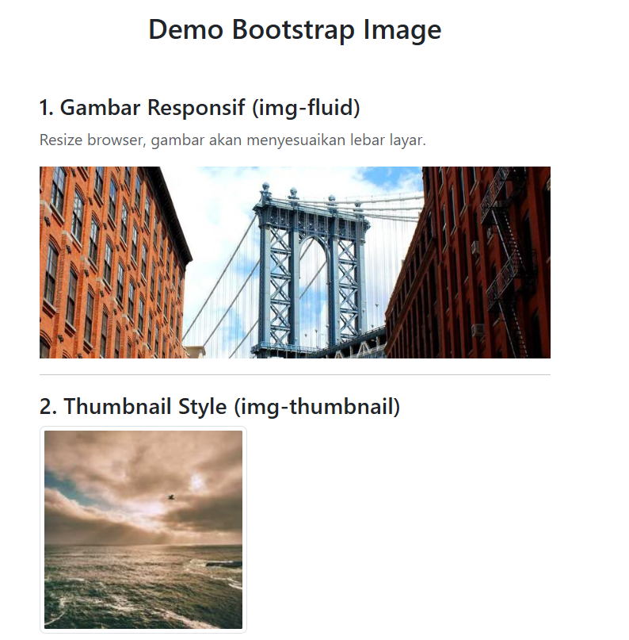

- Bootstrap Button
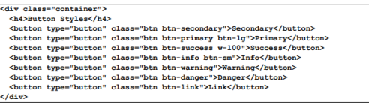
<!DOCTYPE html>
<html lang="id">
<head>
<meta charset="UTF-8">
<meta name="viewport" content="width=device-width, initial-scale=1.0">
<title>Bootstrap Button</title>
<link href="https://cdn.jsdelivr.net/npm/bootstrap@5.3.0/dist/css/bootstrap.min.css" rel="stylesheet">
</head>
<body>

<div class="container mt-5">
<h2 class="text-center mb-5">Demo Bootstrap Button</h2>

<!-- 1. Basic Buttons -->
<h4>1. Basic Buttons</h4>
<div class="mb-4">
<button type="button" class="btn btn-primary">Primary</button>
<button type="button" class="btn btn-secondary">Secondary</button>
<button type="button" class="btn btn-success">Success</button>
<button type="button" class="btn btn-danger">Danger</button>
<button type="button" class="btn btn-warning">Warning</button>
<button type="button" class="btn btn-info text-white">Info</button>
<button type="button" class="btn btn-light border">Light</button>
<button type="button" class="btn btn-dark">Dark</button>
<button type="button" class="btn btn-link">Link Style</button>
</div>

<!-- 2. Outline Buttons -->
<h4>2. Outline Buttons</h4>
<div class="mb-4">
<button type="button" class="btn btn-outline-primary">Primary</button>
<button type="button" class="btn btn-outline-secondary">Secondary</button>
<button type="button" class="btn btn-outline-success">Success</button>
<button type="button" class="btn btn-outline-danger">Danger</button>
<button type="button" class="btn btn-outline-warning">Warning</button>
<button type="button" class="btn btn-outline-info">Info</button>
<button type="button" class="btn btn-outline-dark">Dark</button>
</div>

<!-- 3. Button Sizes -->
<h4>3. Button Sizes</h4>
<div class="mb-4">
<button type="button" class="btn btn-primary btn-sm">Small Button</button>
<button type="button" class="btn btn-primary">Default Button</button>
<button type="button" class="btn btn-primary btn-lg">Large Button</button>
</div>

<!-- 4. Block / Full Width Button -->
<h4>4. Block Button (Full Width)</h4>
<div class="d-grid gap-2 col-6 mx-auto mb-4">
<button class="btn btn-success" type="button">Block Button</button>
<button class="btn btn-outline-primary" type="button">Block Outline Button</button>
</div>

<!-- 5. Disabled State -->
<h4>5. Disabled Button</h4>
<div class="mb-4">
<button type="button" class="btn btn-primary" disabled>Disabled Button</button>
<a href="#" class="btn btn-secondary disabled" tabindex="-1" role="button" aria-disabled="true">Disabled Link</a>
</div>

<!-- 6. Button Group -->
<h4>6. Button Group</h4>
<div class="btn-group mb-4" role="group" aria-label="Basic example">
<button type="button" class="btn btn-primary">Left</button>
<button type="button" class="btn btn-primary">Middle</button>
<button type="button" class="btn btn-primary">Right</button>
</div>

</div>

<script src="https://cdn.jsdelivr.net/npm/bootstrap@5.3.0/dist/js/bootstrap.bundle.min.js"></script>
</body>
</html>

Output:
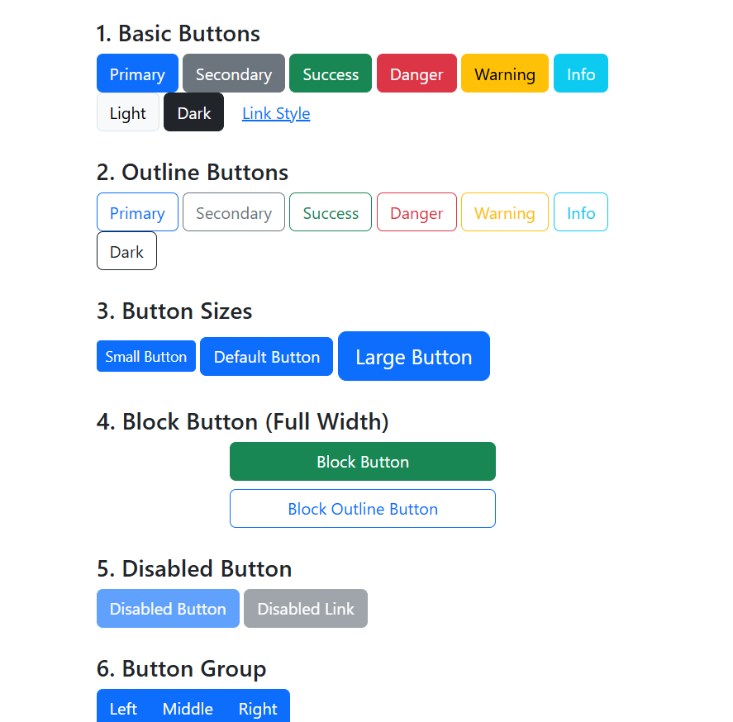
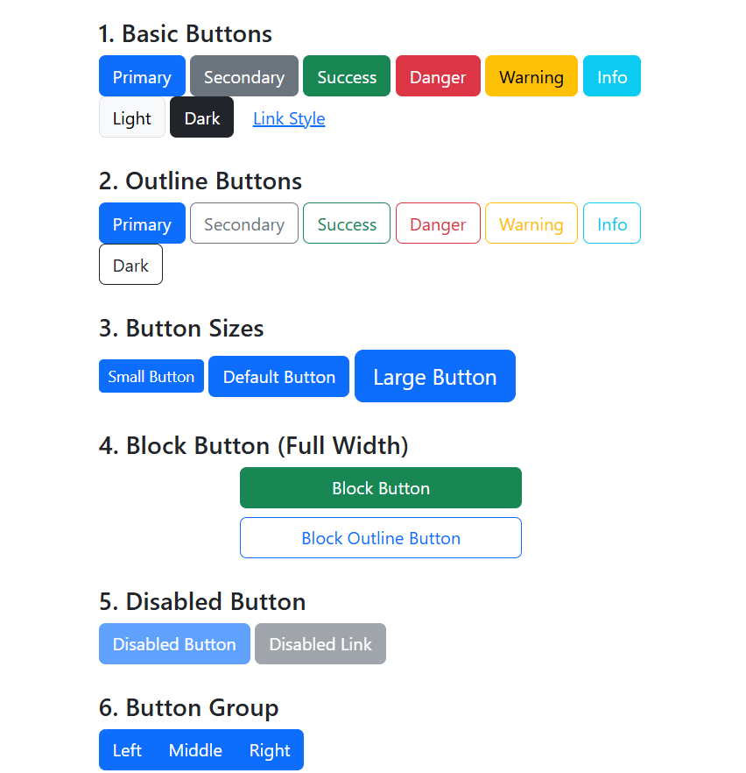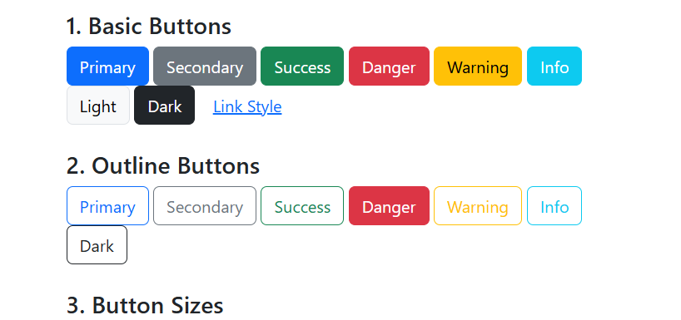
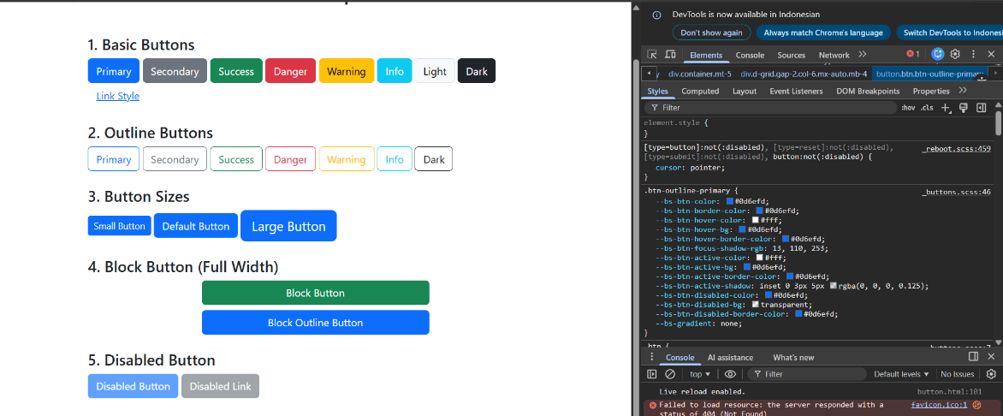

- Bootstrap Form
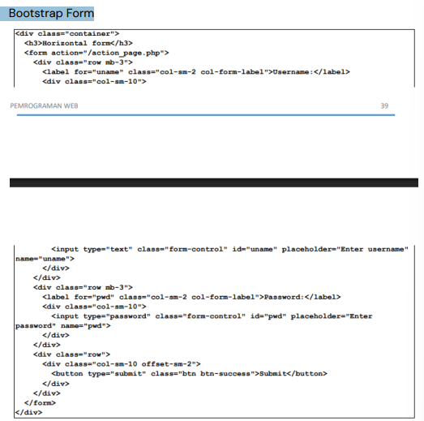
<!DOCTYPE html>
<html lang="id">
<head>
<meta charset="UTF-8">
<meta name="viewport" content="width=device-width, initial-scale=1.0">
<title>Bootstrap Form</title>
<link href="https://cdn.jsdelivr.net/npm/bootstrap@5.3.0/dist/css/bootstrap.min.css" rel="stylesheet">
</head>
<body>

<div class="container mt-5">
<h2 class="text-center mb-5">Demo Bootstrap Form</h2>

<div class="card p-4">
<h4 class="mb-3">Form Login (Horizontal)</h4>
<form action="action_page.php">

<!-- Baris 1: Username -->
<div class="row mb-3">
<label for="username" class="col-sm-2 col-form-label">Username</label>
<div class="col-sm-10">
<input type="text" class="form-control" id="username" placeholder="Masukkan nama pengguna">
</div>
</div>

<!-- Baris 2: Password -->
<div class="row mb-3">
<label for="password" class="col-sm-2 col-form-label">Password</label>
<div class="col-sm-10">
<input type="password" class="form-control" id="password" placeholder="Masukkan password">
</div>
</div>

<!-- Baris 3: Email (Contoh tambahan) -->
<div class="row mb-3">
<label for="email" class="col-sm-2 col-form-label">Email</label>
<div class="col-sm-10">
<input type="email" class="form-control" id="email" placeholder="name@example.com">
</div>
</div>

<!-- Baris 4: Tombol Submit -->
<!-- offset-sm-2 digunakan agar tombol sejajar dengan input, bukan di bawah label -->
<div class="row mb-3">
<div class="col-sm-10 offset-sm-2">
<button type="submit" class="btn btn-primary">Login</button>
<button type="reset" class="btn btn-secondary">Reset</button>
</div>
</div>

</form>
</div>
</div>

<script src="https://cdn.jsdelivr.net/npm/bootstrap@5.3.0/dist/js/bootstrap.bundle.min.js"></script>
</body>
</html>

Output:
